# AVR Programming without IDE

To code and compile AVR projects we can use linux command line tools , AVR toolchain and Makefile  
Need to install

* Install wsl linux (Ubuntu)
* Install AVR toolchain
* Install make

Here we will be using Ubuntu terminal for installing dependencies (avr toolchain, make) and for compilation of source file

## Install WSL Linux (Ubuntu)

1. Search for “Turn widows feature on or off” and click open.  
   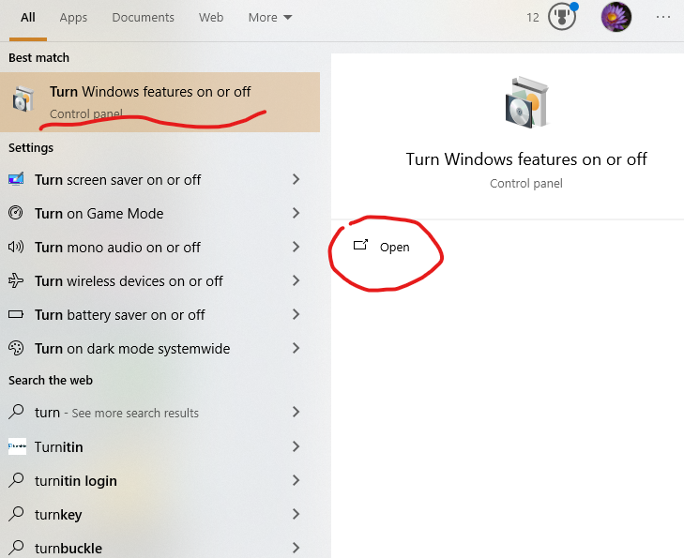
2. Enable checkbox “Windows Subsystem for Linux”, click ok. Then wsl installation starts and asks for Restart. Click “restart now” and restart your PC.   
   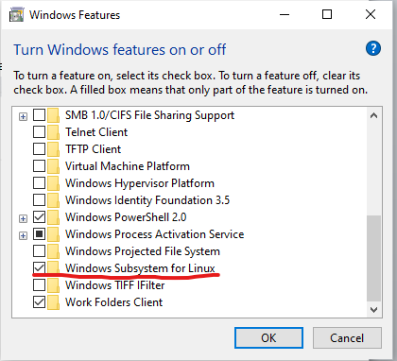
3. After restart, go to windows -> Microsoft store -> search for linux or Ubuntu, install Ubuntu.  
   After downloading open ubuntu  
   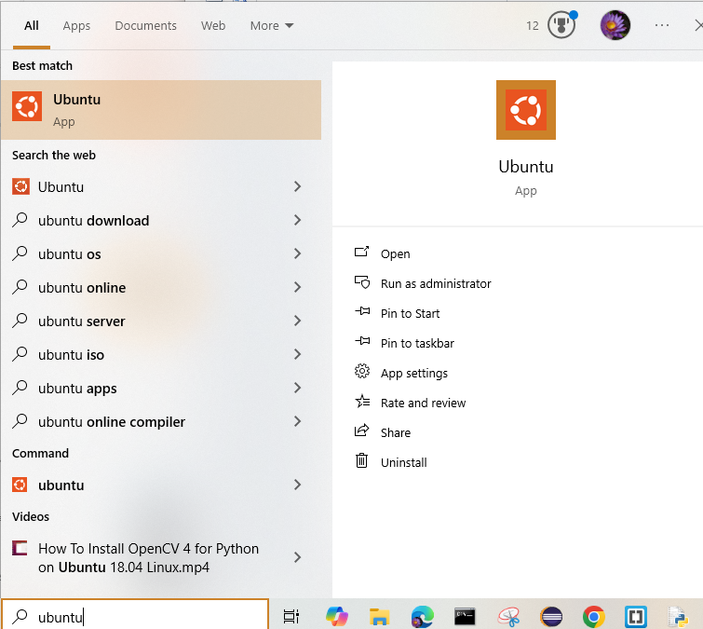
4. When opening ubuntu for first time it will take some time(in terminal window) for installation  
   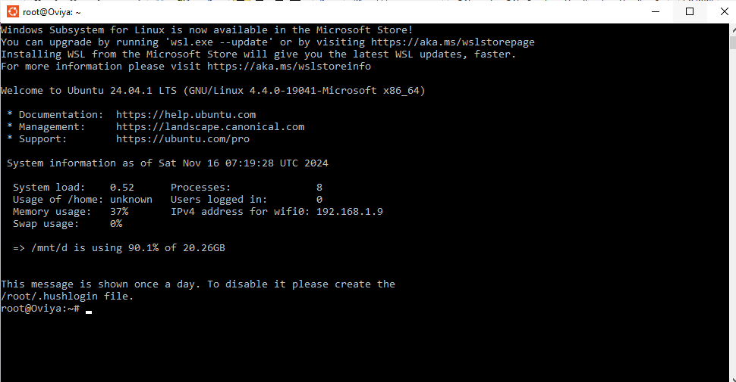

## Install AVR Toolchain.

Install avr gcc and other required items  
$sudo apt-get install gcc-avr binutils-avr avr-libc gdb-avr

## Install Make

Update  
$ sudo apt update

Check make is installed or not  
$make –version

Install make  
$sudo apt install make

# Create a first blink led project using( AVR toolchain + Makefile)

1. Create blink.c file in anu directory, Im my case I’ll create it in G drive which was present in windows.  
   Linux connand to navigate to g drive  
   $cd /mnt/g  
   create a folder named blink  
   $mkdir blink  
   create blink.c and Makefile  
   $touch blink.c Makefile
2. Blink.c file c code

// Default clock source is internal 8MHz RC oscillator

#define F_CPU 8000000UL

#include <avr/io.h>

#include <util/delay.h>

int main()

{

    DDRB |= (1 << PB0);

    while (1)

    {

        PORTB |= (1 << PB0);

        _delay_ms(1000);

        PORTB &= ~(1 << PB0);

        _delay_ms(1000);

    }

    return 0;

}

Makefile

build:

    avr-gcc -mmcu=atmega328p -Wall -Os -o led.elf main.c

    avr-objcopy -j .text -j .data -O ihex led.elf led.hex

In terminal run below command, to build the project and generate a hex file  
$make